

**INDIVIDUAL ASSIGNMENT**

**TECHNOLOGY PARK MALAYSIA**

**CT005-4-0-IVIP**

**INTRODUCTION TO VISUAL & INTERACTIVE PROGRAMMING**

**UCFF2209CT**



**LECTURER:   AZIAH BINTI ABDOLLAH**

|  |  |  |
| --- | --- | --- |
| **NUM.** | **STUDENT’S NAME** | **TP NUMBER** |
| **1.** | **MANREEN KAUR A/P JAGJIT SINGH** | **TP071290** |

Contents

DESCRIPTION OF THE PROGRAM 3

STRATEGY PLANNING 4

PROGRAM DESIGN 6

ABSTRACTING AND MODULARIZING 6

FLOWCHART 10

TEST RESULTS 11

USER’S MANUAL BOOK 15

CONCLUSION 21

REFERENCES 22

# DESCRIPTION OF THE PROGRAM

A maze game is played by both adults and children. Based on this application used which is named SNAP! is an example platform utilized by the programmer to build this game. This game is more suitable for ages between 4 – 9 years old due to the structure of the game which is less complicated. This program is created and made in various designs to attract users, so they get hooked on them. Practicing mazes is not only beneficial for adolescents but also favorable to addressing and highlighting various capabilities of kids. The objective of this application is to enable users to develop problem-solving skills. This game aids kids to work on executive functioning skills, for instance, developing strategic plans and brainstorming. Moreover, the youths can enhance cognitive skills by allowing these kids to think, reason, and remember, concurrently sharpening their memory to construct and strengthen concentration ranking. Furthermore, before children begin to solve the maze, they plan their moves by scanning their eyes on the maze circuit to find possible effective solutions which strengthens their visual power and ability to scrutinize complex settings triumphantly in tricky circumstances. Their mind is working with fingers able to track the maze without getting eaten by the monsters by playing cautiously. Besides, mazes are complicated and take time to figure out. By playing this application, the user will value persistence and stay patient without giving up as their hard work would not be futile. In addition, playing mazes will aid in building the child’s confidence and pride in accomplishing and motivating them to play more. To summarize, the user must finish the game by reaching the treasure box without touching any monsters that act as an obstacle for the character. The user also must find the best possible route and accurate timing to escape from the monsters before the time ends. Then the best time without getting eaten by the monster will be ranked accordingly.

# STRATEGY PLANNING

The first step when it comes to strategic planning in the project is planning. This planning involves numerous brainstorming ideas to create and build a strong and secure platform for users to play. First and foremost, to create this game I am obligated to understand the requirements to build the game. To build a successful game for users, I collect data and resources by researching things that makes user attracted to this game. This video game created is a maze game that utilizes animation, music, graphics, and more. I used characters and backgrounds to be more colorful and contrasting so that it looks interesting for the user’s first impression. The next step is to identify my skills to come up with an idea for a game that can be either amazing in arts or coding. The third step is to decide the aims and goals of the game. The following step is deciding how to communicate with the player. Based on this application, the user can click on the buttons like the info icon to see how the game works. Then, in the following step, I decide the obstacles that the user will face so that it will be trickier for the user to finish the game. The final step of strategic planning is figuring out the rules implied in this platform, I used numerous rules such as consequences faced by the user when touches the enemy, a top 5 list of the scoring system, and a timer so that the user knows how to manage time to win the game without making mistakes. The next step is rewarding the user reward. Since the user faces obstacles, the user should also gain rewards for a satisfying experience.

In this process, I picked SNAP! to develop my game as my game engine which renders the graphics and music. Not only that but using this engine, I am able to control the game physics, collision detection, and scripting. Based on my experience over the last 2 months, I have gained lots of knowledge and skills from learning how to use this search engine. I find using this search engine is a convenient application to seek help using YouTube and other conversation platforms that aid or are seeking help beginners. I also set a deadline for creating my game so that I can estimate the time taken to build and plan. As well as if some surprising turn of complications that messes up the process. Besides, I also test my game before launching for users to globally access this game so that there won’t be any bugs or other implications that impact a successful project. Finally, I can launch my project.

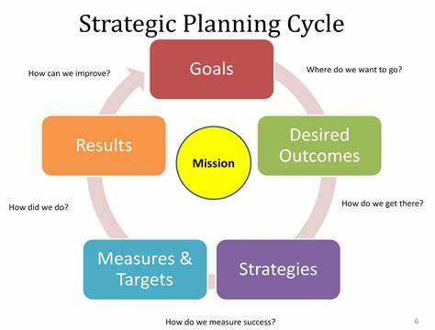

# PROGRAM DESIGN

## ABSTRACTING AND MODULARIZING

*Exploring connections between the whole and the parts*

|  |
| --- |
| Decide what sprites are needed for your project and describe each of the sprites. |

|  |  |
| --- | --- |
|  | * This sprite is clicked by the user if the user would like to start the game. |
|  | * This sprite is used for users to see what a leaderboard is. * This leaderboard contains the name and speed of the winner. |
|  | * This sprite is used for the user to click and see what is under the info icon. * This info icon contains information about the game for example how the sprite moves |
|  | * This sprite’s name is “Captain Hook”. * This sprite is used to ask and say user what to click. * This sprite has a conversation with the user. |
|  | * This sprite’s name is “Night Fury”. * This sprite is used to have a conversation with “Captain Hook”. * This sprite is a character for the user to use in the maze. * This sprite can move up, down, left, right, and stop. * This sprite must avoid touching any “Monsters” and finish the game under 180 seconds to win the game. |
|  | * This sprite is used as an obstacle for “Night Fury”. * If the “Night Fury” touches these sprites the “Night Fury” losses the game. |
|  | * This sprite is used to reward the user. |

|  |
| --- |
| Decide what scripts are needed for your project and what they should do. |

|  |  |
| --- | --- |
|  | * When this script is clicked the script below will run. * This script allows changing size, move to the next position, ask, say, show and hide variables. |
|  | * When this script is clicked the code below will function based on the broadcast code used. * This script is used in the conversation. * This script allows to say, change position, and broadcast messages. |

|  |
| --- |
| Describe all backdrop used in the project |

|  |  |
| --- | --- |
|  | * This background is used for the cover page. * This background introduces what the game is by displaying icons about the game. |
|  | * This background is used for the conversations between “Captain Hook” and the “Night Fury”. |
|  | * This background is used for player to play the maze game. |
|  | * This background is used for ending the conversation between “Captain Hook” and “Night Fury”. |

|  |
| --- |
| Describe the sound used in the project |

|  |  |
| --- | --- |
| [Captain Hook- He's A Pirate](https://www.youtube.com/embed/7Du_C2vcZUg?feature=oembed) | * This sound is used in the maze scene. |

|  |
| --- |
| List all instruction to listing all projects |

|  |  |
| --- | --- |
|  | * The space button is clicked to stop the sprite from moving in the maze. * The up-arrow key is used to move up. * The down-arrow key is used to move down. * The left-arrow key is used to move left. * The right-arrow key is used to move right. |

|  |  |  |
| --- | --- | --- |
| Describe the following phases in your project? | Early stage | * Practice and watch videos to get ideas to make the game. |
| Middle | * Apply the codes to make the maze by separating each character’s code. |
| Finish | * Test and make sure the game is free from bugs and fix the errors. |

|  |
| --- |
| List all variables used in the project |

|  |
| --- |
|  |
| * High score * High_core_helper * Name * Score * Score_pos * Timer |

## FLOWCHART

START

DO YOU WANT TO STEAL MY TREASURE?

DECLARE VARIABLES AS “9”, “Yes” or “No”

“9”

“No”

“Yes”

**REPEAT**

PROCESS

END

# TEST RESULTS

As part of the project design process you will need to debug your project. This means that you must test the different parts of your project to make sure it is working correctly.

|  |  |  |  |
| --- | --- | --- | --- |
| Test ID | Test Case | Expected Results | Actual results |
| Begin  scene for Captain Hook. | When the green flag is clicked. | Say the user to type “9” to ask again or type “Yes” or “No” if the user is here to steal the treasure. Click on the start icon to play, the leaderboard icon to see the leaderboard, or the info icon to see the guidance on how to play the game. | Say the user to type “9” to ask again or type “Yes” or “No” if the user is here to steal the treasure. Click on the start icon to play, the leaderboard icon to see the leaderboard, or the info icon to see the guidance on how to play the game. |
| Begin scene start icon. | When the I am clicked button is pressed. | If the answer is “Yes” then switch to the conversation scene.  If the answer is “No” then switch the to end scene.  If the answer is “9” repeat the question. | If the answer is “Yes” then switch to the conversation scene.  If the answer is “No” then switch the to end scene.  If the answer is “9” repeat the question. |
| Begin scene leaderboard icon. | When I am clicked button is pressed. | Switch to the leaderboard icon, say “You clicked me”, and switch costume when any key is clicked. | Switch to the leaderboard icon, say “You clicked me”, and switch costume when any key is clicked. |
| Begin scene info icon. | When I am clicked button is pressed. | Switch the info icon to the keyboard costume. | Switch the info icon to the info script. |
| Conversation scene Night Fury. | When the green flag is clicked. | Say you clicked me. Broadcast to Captain Hook. | Say you clicked me. Broadcast to Captain Hook. |
| Conversation scene Captain Hook. | When I receive Captain Hook. | Say “This is my treasure. What makes you think you can find it!”  Say “Perhaps you should give up because I am the greatest.”  Broadcast Night Fury. | Say “This is my treasure. What makes you think you can find it!”  Say “Perhaps you should give up because I am the greatest.”  Broadcast Night Fury. |
| Conversation scene Night Fury. | When I receive Night Fury. | Say “Never! Never!!!!!” | Say “Never! Never!!!!!” |
| Conversation scene Captain Hook. | When I receive Captain Hook 1. | Say “Keep saying that to yourself darling! 😊”.  Broadcast Night Fury 1. | Say “Keep saying that to yourself darling! 😊”.  Broadcast Night Fury 1. |
| Conversation scene Night Fury. | When I receive Night Fury 1. | Say just wait and watch. I’ll show you my power! Soon you will be nothing. | Say just wait and watch. I’ll show you my power! Soon you will be nothing. |
| Maze scene (m1). | M1 should continuously gliding in the background of the maze scene at the back layer. | M1 is continuously gliding in the background of the maze scene at the back layer. | M1 does continuously gliding in the background of the maze scene at the back layer. |
| Maze scene (m2). | M2 should continuously gliding in the background of the maze scene at the back layer. | M2 is continuously gliding in the background of the maze scene at the back layer. | M2 does continuously gliding in the background of the maze scene at the back layer. |
| Maze scene (m3). | M3 should continuously gliding in the background of the maze scene at the back layer. | M3 is continuously gliding in the background of the maze scene at the back layer. | M3 does continuously gliding in the background of the maze scene at the back layer. |
| Maze scene Night Fury. | When the Night Fury touches the treasure, the user wins. If the Night Fury touches the monster or does not finish the game within the time limit then the game restarts. | If Night Fury touches the treasure without touching any monster within the time limit the user wins and will broadcast to the end scene.  If the Night fury does not touch the treasure and the time ends, then the player losses and restarts the game. | Night Fury touches the treasure and broadcasts to the end scene by completing the maze without touching any monster and touches the treasure within the time limit.  If the user does not touch the treasure or does not finish the game, then the game will restart.  If the user touches the monster then the game will restart. |
| Maze scene Night Fury. | When the green flag is clicked. | Night Fury moves using the arrow key buttons and stops using the space keyword.  Night Fury cannot go through the walls. | Night Fury is moving using the arrow key buttons and stops using the space keyword.  Night Fury goes through the walls. |
| Maze scene treasure. | When Night Fury touch the treasure the player wins if not the game restarts. | When Night Fury touch the treasure so the user will be rewarded and goes to the end scene but if the user does not touch the treasure then the game will be repeated until the user touches the treasure to win. | Night Fury touching the treasure and the user wins and goes to the end scene but when the user does not touch the treasure then the game repeats until the Night Fury touches the treasure. |
| End scene Captain hook. | When the green flag is clicked | Captain Hook says Oh noo! You won.  This is madness and broadcast to night fury and waits. | Captain Hook says Oh noo! You won.  This is madness and broadcast to night fury and waits. |
| End scene Night fury | When I receive Night Fury | Say “HAHAHAHAHAHAHA”. and says “So long noob!”.  Broadcast Captain hook and wait. | Say “HAHAHAHAHAHAHA”. and says “So long noob!”.  Broadcast Captain hook and wait. |
| End scene Captain hook. | When I receive Captain hook. | Say “Not all treasure is silver and gold mate”. | Say “Not all treasure is silver and gold mate.” |
| My music | When the user start’s the game then the music will play. | When the player starts playing the music also starts playing | When the player starts playing the music also starts playing but the music does not continuously play until the game ends unless if the user restarts the game. |
| Score list | The user can see the list on the screen. | This list includes time, name, and the top 5 highest scores. | The list can only display time and name but outside the list. No top five highest score displayed in the list. |

# USER’S MANUAL BOOK

This user manual book shows and illustrates guidance for using the SNAP! BYOB software.

1. The user must open snap.berkeley.edu using a computer, laptop, MacBook, or smartphone to access the game.

1. The user must create an account to log into SNAP!

1. The user can also open the game if the user has previously created an account. Based on the previous account user can input the logging requirements.

1. The user can play the game after receiving access from the programmer.

1. The user can choose to see the code, download, embed, and see the collection. The user can also check publishing information of the game too.

1. The user can also download the file and play directly in the SNAP! If the user is able to access the file from the programmer.

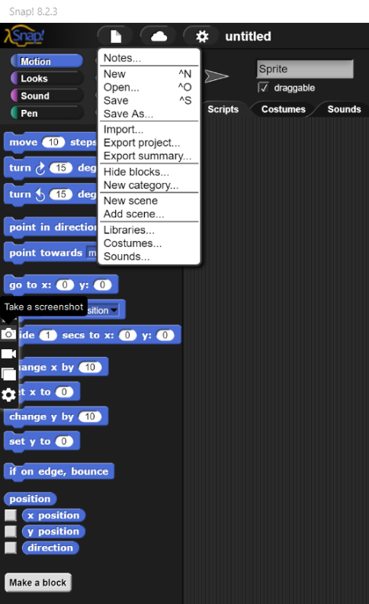

1. The user can choose the following icons

1. If the user chooses to start, then the game will be broadcast to the conversation scene. If the user chooses the Leader board icon, then the leader board will be displayed. If the user chooses info icon, then the info will be displayed.

1. This is the conversation scene played before the game begins.

1. Once the conversation scene is over it will broadcast to maze scene. This is where the user plays the maze.

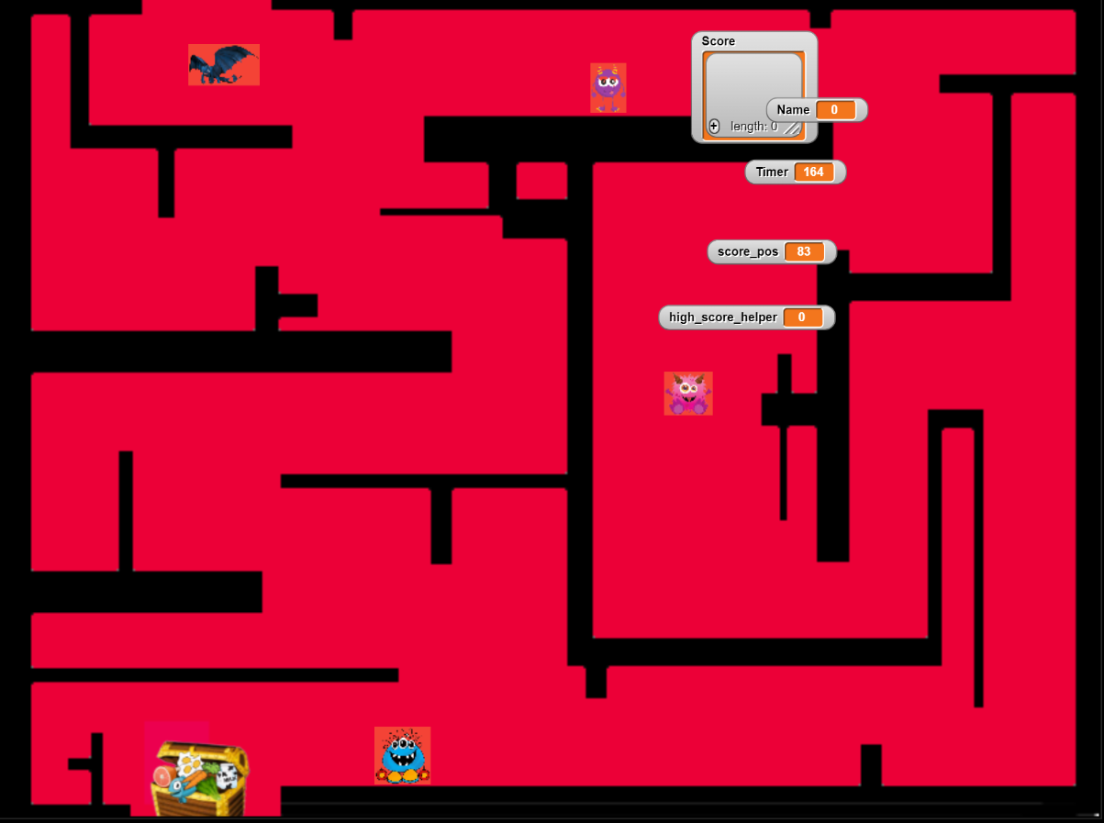

1. This is how the game ends with a little bit of conversation between Night Fury and Captain Hook.

# CONCLUSION

To conclude, based on my examination of utilizing this application there are various capabilities found in this game however there are also limitations found when I was writing this project.

The capabilities found in the project are my abilities to learn as a beginner in a programming language which is easier to comprehend the message and how it works compared to other languages. This application is based on drag-and-drop codes and a little bit of creating variables and other block scripts. This application allows me to customize my sprite’s motion and looks. I can choose costumes and backgrounds, or I could import my images into this application. Not only that but I can also add audio directly from the SNAP! as well as record my own music. Moreover, I can also draw using the pen sensing script and make my own variables to design the shape and size of the drawing. Furthermore, in the control sense, I can drag the codes for instance when I am clicked and set the motions and then broadcast to other sprites after adjusting how long should the script wait. I can add control structures such as forever, if conditions, repetition, and many others to write my code. Besides, I can ask user questions using the sensing block and set a timer. In addition, operators such as multiplication and division can be inserted to write my code. In addition, in the variable block creating variables, lists, and showing or hiding variables can be found in the variable section. Finally, I can make notes, save or open files, import or export projects, and add scenes to this software. My personal favorite part of this software is the ability to design and view my project for the way it runs.

Whereas the limitations found in this application are unable to upload GIF images and the application often runs buggy. Based on my personal experience, my project’s backgrounds went missing but my scripts were there even though I have saved them numerous times. Moreover, this application takes up too much storage and each file saved depending on the size file is huge. Apart from that, this project often runs disorganized and sophisticated when I operate the code. Some of the blocks are not located in the regular engine which causes difficulties for programmers to create a code.

# REFERENCES

1. 20 June 2009. Captain hook- he's a pirate. YouTube. <https://www.youtube.com/watch?v=7Du_C2vcZUg&t=5s>
2. 10 July 2020. What is strategic planning. Management Guru.

<http://www.managementguru.net/strategic-planning/>

1. Download clipart - thank you for using WebStockReview.

<https://webstockreview.net/pict/getfirst>

1. Night fury PNG image with transparent background. pngimg.com

<https://pngimg.com/image/84906>

1. Cute monster clipart. Cliparts

<http://cliparts.co/cute-monster-clipart>

1. Www.fourlittlemonsters.com. Four Little Monsters Blog

<http://fourlittlemonsters.homestead.com/index.html?entry=monster-baby-days-is-here>

1. Game backgrounds. Wallpapersafari.

<https://wallpapersafari.com/w/Hbios0>